**DATA WAREHOUSING AND DATA MINING**

**END SEMESTER PRACTICAL EXAMINATION**

**NAME: PAVITHRA N**

**ROLL NO:18BCS082**

**DATE:23.06.2021**

1. Download a sample dataset from any Repository. List the attributes and its type in a word Doc.

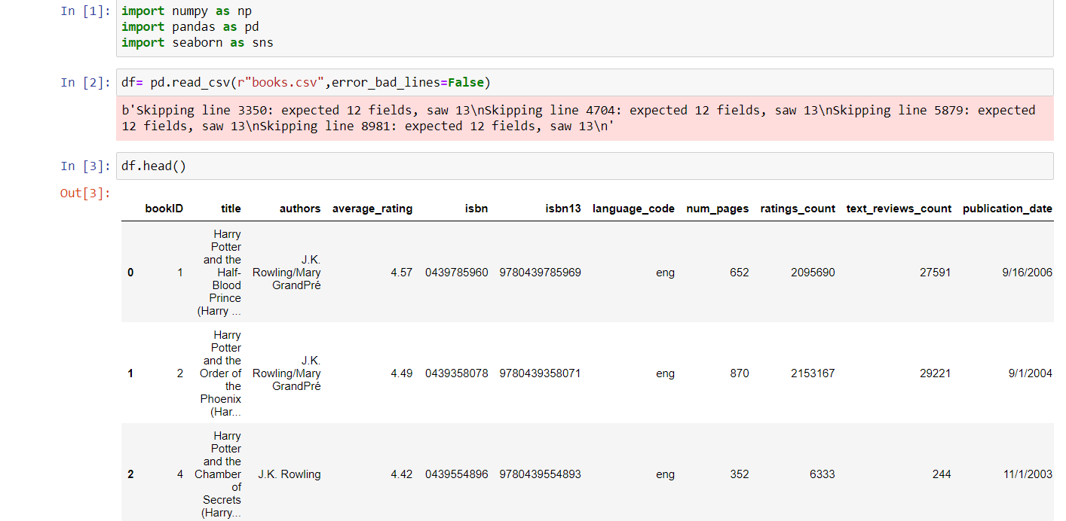

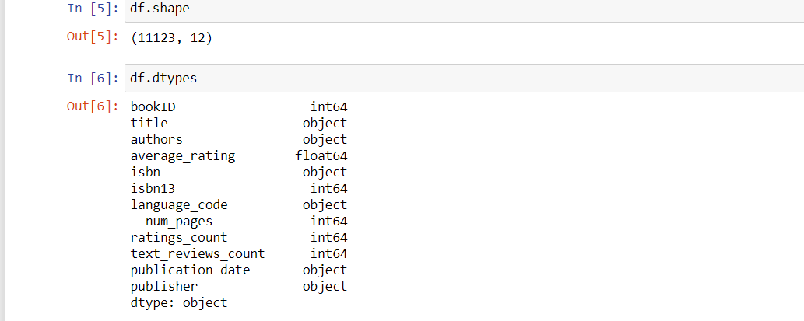

**ATTRIBUTES DESCRIPTION:**

1.Bookid-Numerical

2.title-Categorical Nominal

3.authors-Categorial Nominal

4.average_rating-numerical continuous

5.ISBN-Numerical discrete

6.ISBN 13-Numerical discrete

7.language_code-categorical nominal

8.Num_pages-Numerical discrete

9.Ratings_count-numerical discrete

10.text_reviews_count-Categorical Nominal

11.publication_date-categorical_nominal

12.publisher-categorical nominal

2. Create a random dataset of 50 elements with x and y variables using random function between 30 to 100 integers for x and 60 to 150 integers for y. Apply K- means clustering to cluster the data into 3 clusters. Plot the graph and display the result. Use Tkinter GUI to Display the Results

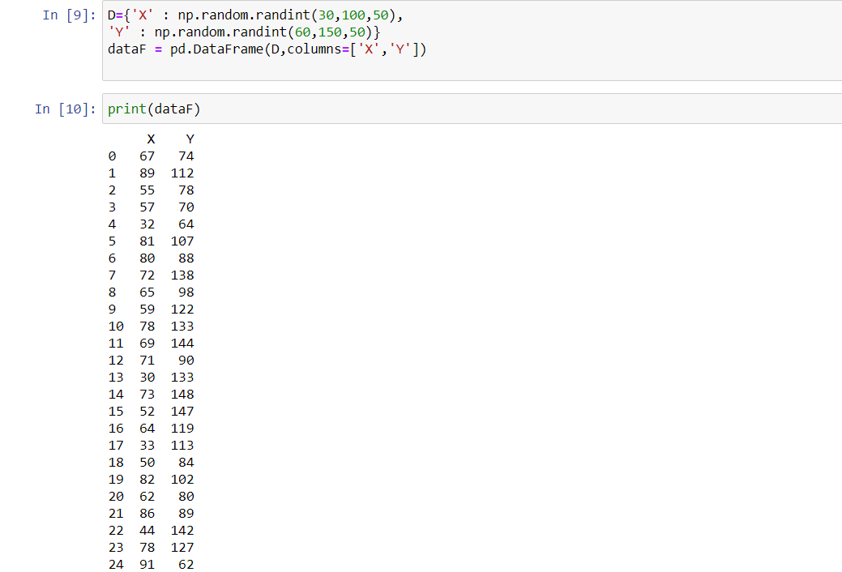

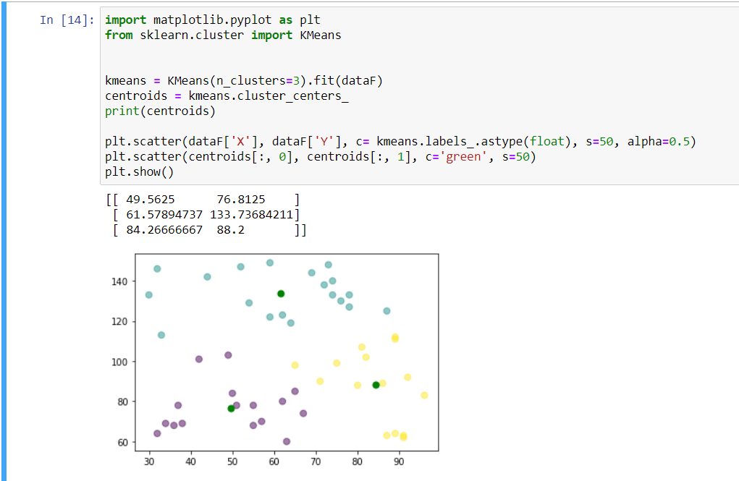

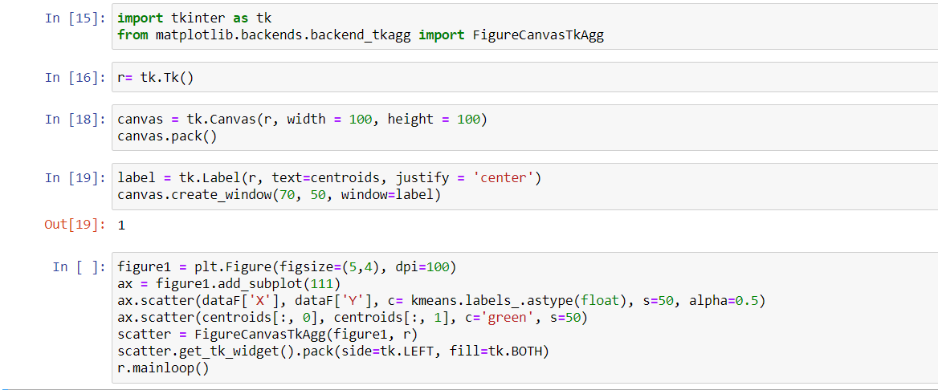

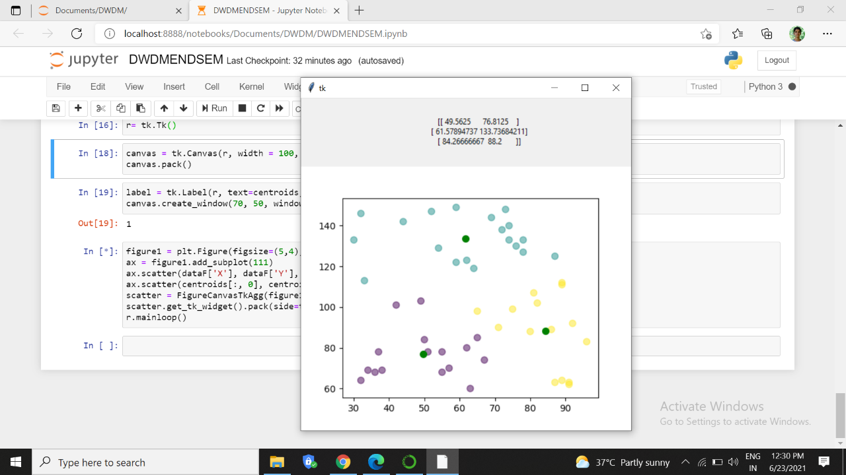

3.Uploading github.

https://github.com/Pavithra-N2001/END-SEM-PRACTICAL

4.

